Task 1

Code:

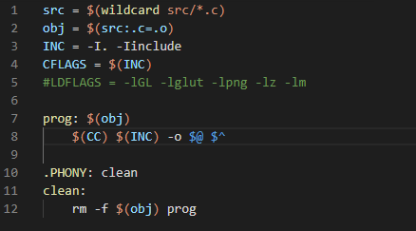

Terminal:

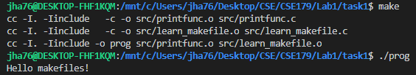

Task 2

Code:

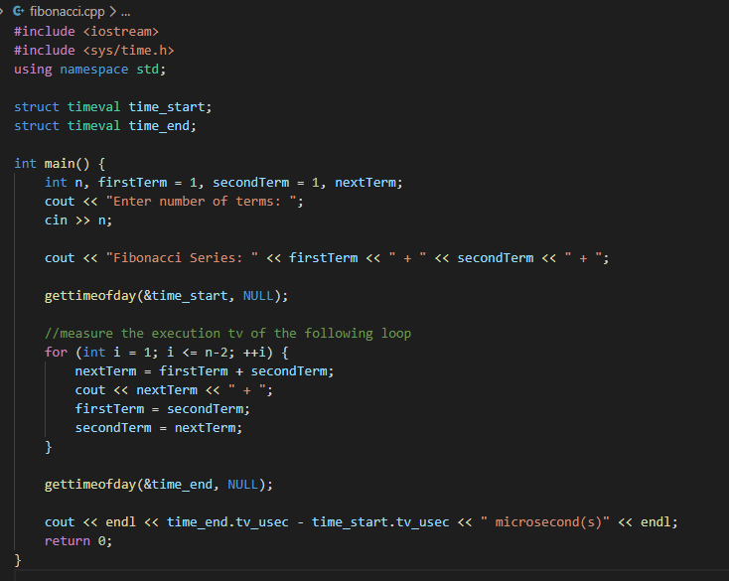

Terminal:

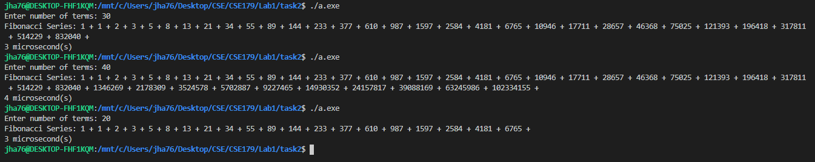

Task 3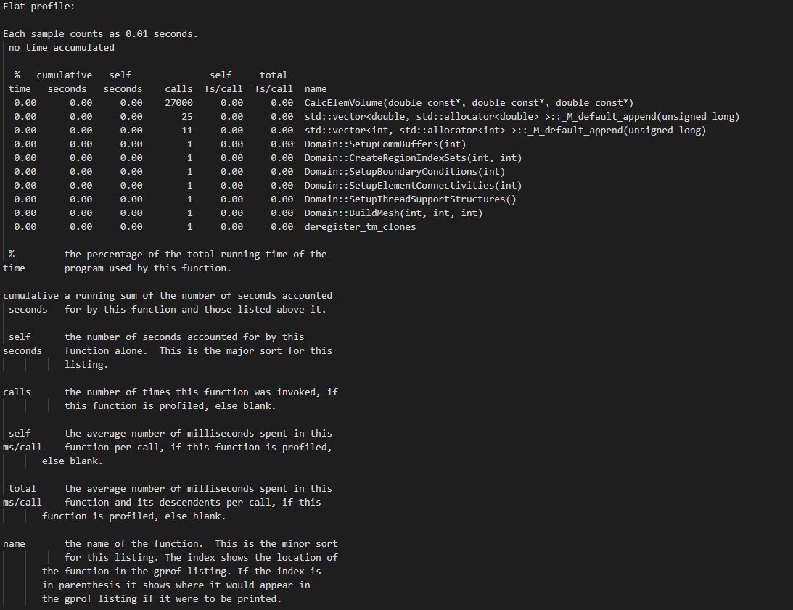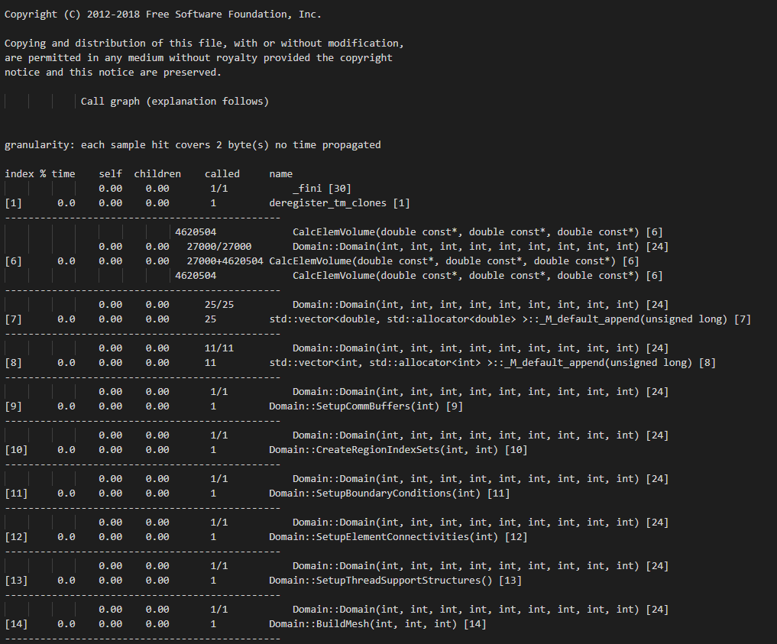

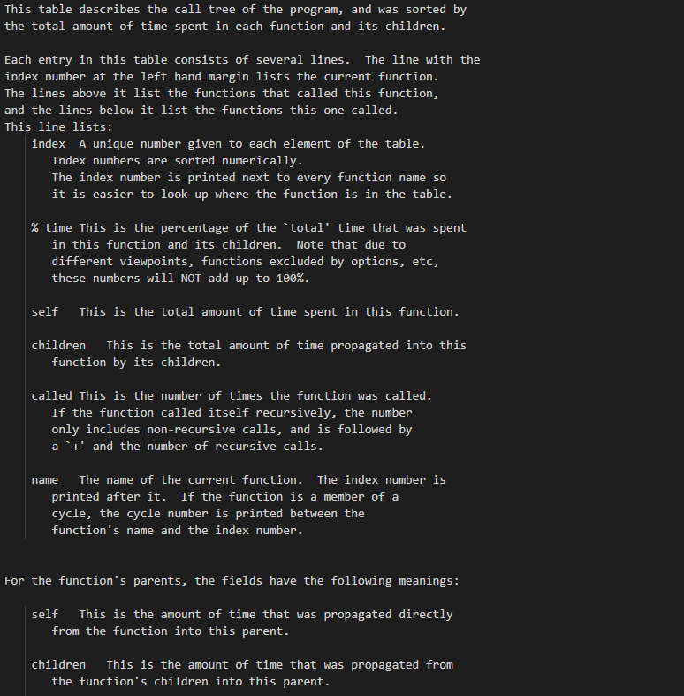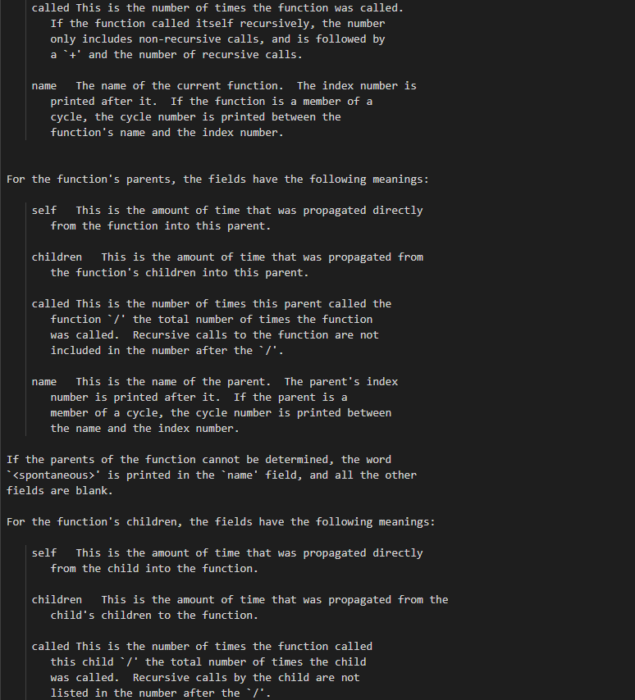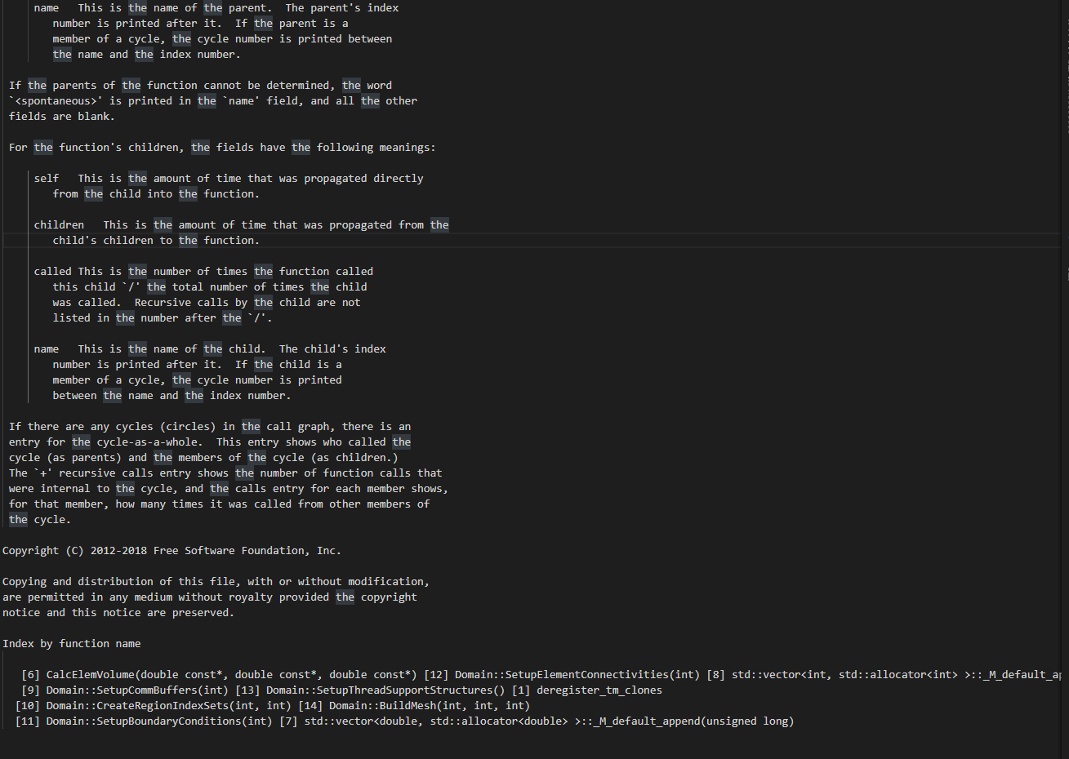

Task 3.2

The call graph is a table of the program’s functions, sorted by the total amount of time spent in each function and its children. The graph also indicates how much time was spent with each parent and child routine individually, as well as the number of times they were called during the runtime.